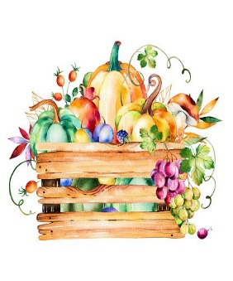

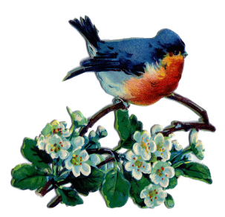***October Good News 2023***

**Our ministry vision for the Virginia Annual Conference is *“to be disciples of Jesus Christ who are lifelong learners, who influence others to serve.”***

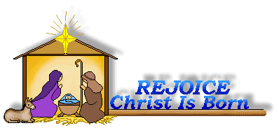

**From Pastor Adam**

“Fall Colors”

*The grass withers, the flower fades, but the word of our God will stand forever.*

*(Isaiah 40:8)*

*While the earth remains, seedtime and harvest, cold and heat, summer and winter,*

*day and night, shall not cease. (Genesis 8:22)*

*E*very now and again I dream about early retirement somewhere tropical, with palm trees and a seemingly endless stream of sunny days. What follows quickly on that thought is the realization of how much I would miss the wonders of Fall. We are most blessed to live in Central Virginia where the weather is temperate, offering rich variety while avoiding extremity. The winters are relatively mild and yet we have just enough snow to make our winter wonderland dreams come true. The summers are generally comfortable, and the fall season is filled with a kaleidoscope of color. We get all the seasons. Just enough of each without too much of one or the other. With September 23 marking the first day of Fall, the season of pumpkin spice coffee and jack-o-lanterns and warm fuzzy sweaters have arrived. While it has been unseasonably warm recently, I trust that the true “feel” of cooler weather will be here soon. I believe the change of seasons presents us with an opportunity for spiritual reflection – the parent death of summer foliage sets the stage for the glorious resurrection of Spring. Everything is perfect in its time. The coolness in the air reminds us that even as the world around us changes, the faithfulness, compassion,

and reliability of our God remains steadfast in all things. The changing rhythms of the earth reminds us that God wills this project of the human experience to continue and flourish throughout the passage of time. The arrival of Fall demonstrates the artfulness, majesty, and rationality of the creation and our Creator. May this Fall season bring us new spiritual reflection and vitality. May we enter into a mystery – that as the weather cools, may our hearts grow warm with the love *of* and *for* God and neighbor.

God bless you my friends, Adam

Circle News****

The Wesleyan Group …We will meet on Monday, October 9, 2023, at 7:00 p.m., at the home of Linda Jessen.

The Merry Marthas Circle will meet on Thursday, October 26, 2023, at 10:00 a.m.

in the OMU room.  A local “field trip “ is in the works. Details to be announced later.

~*Judy Robertson*

*Mission Memo*

For September the food cart contained 84lbs of food and 7lbs of hygiene products. Park View Mission is always thankful for our faithful support.

In October we are collecting canned green beans, corn, yams, and cranberry sauce. Also boxes of instant mashed potatoes and stuffing mix.

~*Linda Jessen & Mission Committee*

**Food Cart..October**

Canned green beans, corn, yams, cranberry sauce, boxed instant mashed potatoes, stuffing mix. *No* ***“baked goods”*** *!* *Place donations in the grocery cart, located in the Commons*.



**The choir** will be singing on Sunday, October 29th, and will be rehearsing

at 10 AM. We will sing familiar hymns so please come join us!

*~Heather Wilson*, Director of Music

***Park View Closet ~ Winter Clothing***

Needed: Park View is now accepting winter clothing. Bring items to church and Linda Jessen will take to the mission. Bring items to church, **Monday—Thursday**, 9:30 a.m. to 3:00 p.m.

**World Communion Sunday**

October 1, 2023

On Sunday, October 1, 2023, we will be receiving World Communion offering. Your gifts on World Communion Sunday provide World Communion scholarships for graduate and undergraduate students from the U.S. and other countries, along with grants to support training for worldwide inclusion, diversity, equity and access. These funds are administered by the United Methodist General Boards of Global Ministries and Higher Education to equip gifted, qualified students from around the globe to become the world changers God created them to be.

**The Mountain View District Palooza** will be held Saturday, **November 11, 2023,** from

9:30 am to 11:30 am at **First UMC in Martinsville** (146 East Main Street, Martinsville). We will start

to gather at 9:00 am with light refreshments, then begin our time together with worship in the

sanctuary at 9:30 am. There will be several opportunities for workshops. **Charge Conferences will be held along with our District Conference**. Make plans to attend with at least one representative from your church.



*I want to personally thank each and everyone* for all the birthday wishes and cards. I am so blessed to have Chestnut Hill in my life. You are a wonderful family. God bless each and every one of you. ~Love, **Monica Y**

**October 2023**

|  |  |  |  |  |  |  |
| --- | --- | --- | --- | --- | --- | --- |
| *Sunday* | *Monday* | *Tuesday* | *Wednesday* | *Thursday* | *Friday* | *Saturday* |
| **1** *18th Sunday after Pentecost*  *World Communion Sunday*  9:30 am Sunday School  10:30 am Worship | **2**  6:00 pm Line Dancing-Camp Meadowlark | **3** | **4** | **5** | **6**  Church Office Closed  10:00 am Homeschool | **7** |
| **8** *19th Sunday after Pentecost*  9:30 am Sunday School  10:30 am Worship | **9 *Columbus Day***  Church Office Closed  6:00 pm Line Dancing-CM  7:00 pm Wesleyan Group | **10**  6:30 pm Homeschool Game Night | **11** | **12** | **13** | **14** |
| **15** *20th Sunday after Pentecost*  9:30 am Sunday School  10:30 am Worship | **16**  6:00 pm Line Dancing-CM | **17** | **18** | **19** | **20**  10:00 am Homeschool | **21** |
| **22** *21st Sunday after Pentecost*  9:30 am Sunday School  10:30 am Worship | **23**  6:00 pm Line Dancing-CM | **24**  6:00 pm  Finance  7:00 pm Administrative Council | **25** | **26**  10:00 am Merry Marthas | **27**  10:00 am Homeschool  4:00 pm Homeschool Halloween Party | **28** |
| **29** *Reformation Sunday*  9:30 am Sunday School  10:00 am Choir  10:30 am Worship | **30**  6:00 pm Line Dancing-CM | **31** | “O taste and see that the Lord is good.” -Psalm 34:8 | | | |

**October**

1  Pat Short 21 Steven Kinzer

2  Emily V. Fernandez 22 C.O. Bell

28 Jacqueline Busic

7 Kenny Busic 29 Wes Robbins

9 Owen Stinnette

Jeremey

VandeBogart

11 Landen Glass

12 Camden Mason

16 Burton Brooks

Terry Palazzi

Anne-Elaine Tiller

20 Erin Ecklund

1 Pat Short

2 Nancy Lee

Emily V.

Fernandez

3 Michael McGlothlin

6 Kirsten Bell

Tim Crist

Dennis Tolley

7 Kenny Busic

Cheryl Powell

9 Owen Stinnette

Jeremey

VandeBogart

11 Landen Glass

12 Camden Mason

14 Wade Ware

16 Burton Brooks

Terry Palazzi

Anne-Elaine Tiller

17 Suzanne

Marshall

Blake Phillips

18 Sharon

Rickmon

19 Connie Yost

20 Erin Ecklund

21 Steven Kinzer

22 C.O. Bell

25 Frankie

Hardwick

28 Jacqueline Busic

Cheryl Thomas

29 Wes Robbins

Ricky Smith

31 Robert Baunach

**2022**

**Birthdays**

**March 2022**

**Our Church Financial Picture**

Through the end of August 2023

General Operating Funds:

Needed to meet our 2023 Budget $ 196,989

Needed to meet our budget to date $ 131,326

Actual receipts to date $ 109,652

Shortage to meet budget to date $ 21,674

Actual expenditures to date $ 107,142

Overage to meet expenses to date $ 2,510

Joy In Missions Funds

Our Giving Goal for 2023 $ 9,600

Needed to meet our goal to date $ 6,400

Actual receipts to date $ 7,775

Special Offerings* (not budgeted):

Received to date $ 7,400

Dispersed to date $ 6,890

*Christmas, Easter, Annual Conference,

World Communion, etc.

**2023 Joy In Mission Donations**

To date, the following amounts have

been paid to the missions indicated.

Budget Spent

1. Missionary Covenant Relationship

$1,000 $ 500

2. Park View Mission, Food for Families

$3,000 $1,760

3. Society of St. Andrew $1,000 $ 500

4. Adult Care Center $ 500 $ 0

5. Blue Ridge Area Food Bank $1,000 $ 500

6. Daily Bread $ 500 $ 250

7. Free Clinic $ 500 $ 0

8. Good Neighbor $ 500 $ 0

9. Habitat for Humanity $ 500 $ 250

10. UMCOR-Non-Administrative $ 500 $ 0

11. Undesignated $ 600 $ 0

Thank you for your generosity.

**Those Who Serve ~ October**

**GREETERS:**

October 1 ~ Betty Taylor

October 8 ~ Judy Robertson

October 15 ~ Ann Robbins

October 22 ~ Maggie Musgrove

October 29 ~ Jane White

**In The Grocery Cart:**

**October**

Canned green beans, corn, yams,

Cranberry sauce, boxed instant

mashed potatoes, stuffing mix.

*No* ***“baked goods”*** *!* *Place donations in*

*the grocery cart, located in the Commons*.

**GOOD NEWS** is

published monthly for members and

friends of Chestnut Hill United

Methodist Church. Send articles to

the church office by the 15th of the

month. (Subject to change).





January 2022

**2022**



**April 2022**

**April 2022**

**March 2022**



*Chestnut Hill United*

*Methodist Church*

4660 Fort Avenue, Lynchburg, VA 24502

Phone Number: 434-239-8423: FAX: 434-239-7209

E-mail: [chestnuthillumc@comcast.net](mailto:chestnuthillumc@comcast.net)

On the web: www.chestnuthillumc.net

Church Office Hours

**Monday-Thursday~**9:00 am—3:30 pm

**Friday~**9:00 am-1:00 pm

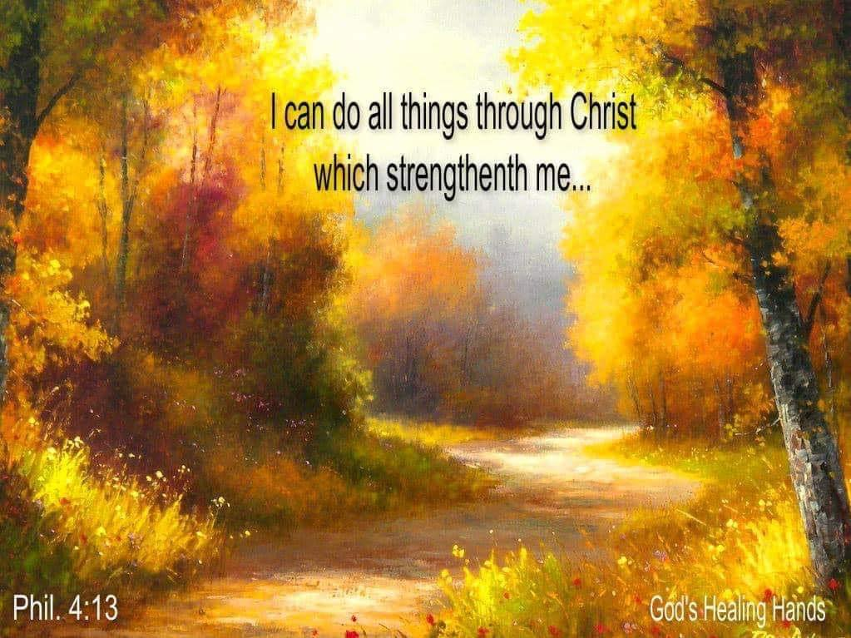

***DIRECTORY OF***

***CHESTNUT HILL UNITED METHODIST CHURCH***

|  |  |  |
| --- | --- | --- |
|  | Sue Haupert-Johnson | Richmond Area Resident Bishop |
|  | Denise Bates | Mountain View District Superintendent |
|  | Adam White | Minister |
|  | Erin Long | Associate Minister |
|  | Monica Campbell | Administrative Assistant |
|  | Heather Wilson | Director of Music Ministry |
|  | Judy Martin | Bookkeeper |
|  | Judy Robertson | Lay Leader |
|  | Elizabeth Nichols | Missionary in Henry County |